Module 1: Introduction to Artificial Intelligence
- What is Artificial Intelligence?

Artificial Intelligence (AI) is a branch of computer science that focuses on creating machines and software that can perform tasks typically requiring human intelligence.
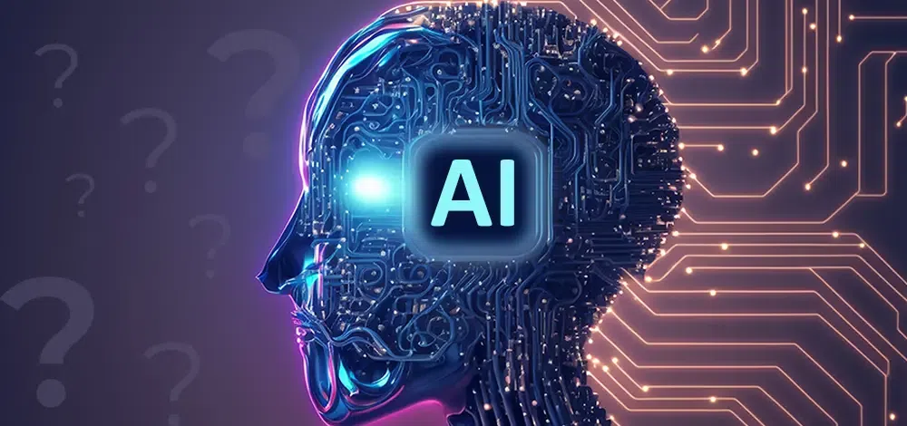

These tasks include:
- Learning (e.g., recognizing patterns, improving with experience)
- Reasoning (e.g., making decisions or solving problems)
- Understanding language (Natural Language Processing or NLP)
- Perception (e.g., recognizing speech, images, or objects)
- Interacting with the environment (e.g., robotics)

Types of AI
- Narrow AI (Weak AI)
  - Designed for a specific task (e.g., Siri, Google Maps, ChatGPT)
- Siri is an easy way to make calls, send texts, use apps, and get things done with just your voice.
- Google Maps enhance navigation, explore the world, AI powers features like real-time traffic prediction, personalized route suggestions, and sustainable travel options.
- ChatGPT is a conversational AI chatbot developed by OpenAI. It's designed to generate human-like text, respond to prompts, and engage in conversations.
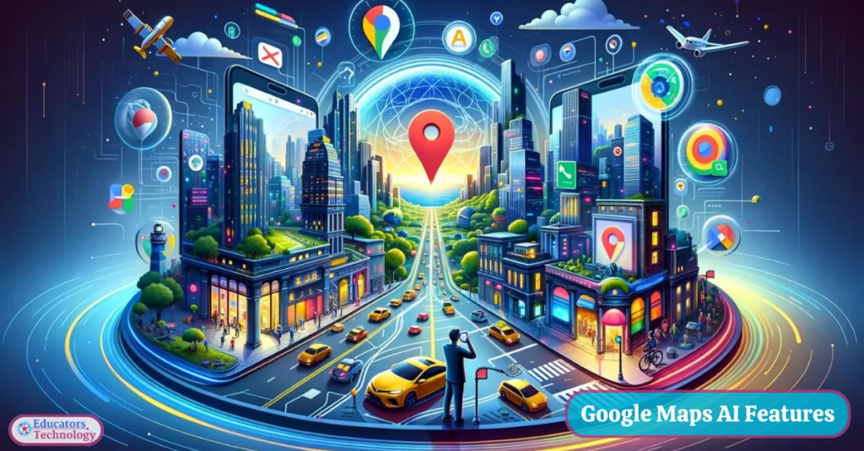

- General AI (Strong AI)
  - Has human-level intelligence across a wide range of tasks (still theoretical)
- Super AI
  - Surpasses human intelligence in all aspects (hypothetical, future concept)

Examples of AI in Use
- Voice assistants like Alexa, Siri
- Self-driving cars (e.g., Tesla)
- Chatbots for customer support
- Recommendation systems (Netflix, YouTube, Amazon)
- Fraud detection in banking

Core Technologies Behind AI
- Machine Learning (ML): AI learns from data (e.g., training a model to predict stock prices)
- Deep Learning: A type of ML using neural networks (e.g., image or speech recognition)
- Natural Language Processing (NLP): Enables machines to understand human language (e.g., ChatGPT)

- History and Evolution of AI
- 1950s – Birth of AI:
- 1956: Term "Artificial Intelligence" coined at the Dartmouth Conference.
- Early programs solved math problems and played games.
- 1970s–80s – AI Winters:
- High expectations but limited technology led to loss of funding and interest.
- 1980s – Expert Systems:
- Rule-based systems used in medicine and business, but hard to scale.
- 1990s – Machine Learning Rises
- Shift to Data-Driven AI:
  - Focus on statistical methods, neural networks, and machine learning.
- Key Milestone:
  - 1997 – IBM's Deep Blue defeated world chess champion Garry Kasparov.

- 2000s – Big Data and Smarter Algorithms
- Better Algorithms + More Data + More Power:
  - AI started being used in search engines, spam filters, recommendation systems, etc.
- Notable Use Cases:
  - Google Translate, early virtual assistants, handwriting recognition.

- 2010s – Deep Learning Revolution
- Neural Networks → Deep Learning:
  - Based on artificial neural networks with many layers.
- Breakthroughs:
  - Image recognition (e.g., AlexNet in 2012)
  - Voice assistants (Siri, Alexa, Google Assistant)
  - 2016 – AlphaGo defeated Go champion Lee Sedol
- AI Everywhere:
  - Healthcare, finance, self-driving cars, social media, etc.

- 2020s – Generative AI and Foundation Models
- Rise of Generative AI:
  - GPT models (by OpenAI), DALL·E, ChatGPT, Sora, Claude, etc.
- Applications:
  - Content creation, customer support, education, programming assistance.
- Foundation Models:
  - Trained on massive datasets; capable of multitask general intelligence.
- Ethical Concerns:
  - Bias(one side), misinformation, job displacement, and AI alignment.

- Applications of AI in Real Life
🔍 1. Healthcare
- Diagnosis & Treatment: AI helps in detecting diseases like cancer (e.g., skin, lung) using imaging.
- Medical Chatbots: Provide symptom checks and health advice (e.g., Ada Health).
- Robotic Surgery: AI-powered robots assist surgeons with precision.
- Drug Discovery: Speeds up new drug development (e.g., DeepMind’s AlphaFold predicts protein structure).

🚗 2. Transportation
- Self-driving Cars: Tesla, Waymo, and others use AI for autonomous vehicles.
- Traffic Management: AI controls signals and predicts traffic patterns.
- Fleet Management: Optimizing routes, fuel usage, and maintenance using AI (e.g., Uber, Ola).

🛒 3. Retail & E-commerce
- Product Recommendations: AI recommends items based on user behavior (Amazon, Flipkart).
- Chatbots & Virtual Assistants: 24/7 customer service (e.g., Meesho’s AI assistant).
- Inventory Management: Predicts demand and manages stock automatically.

📱 4. Smartphones & Gadgets
- Voice Assistants: Siri, Alexa, Google Assistant use AI for speech recognition and natural language processing.
- Face Recognition: Used for phone unlocking and security.
- Camera Enhancements: AI improves image quality and adds effects in real time.

📷 5. Social Media
- Content Curation: AI recommends posts, reels, and ads (e.g., Instagram, YouTube).
- Moderation: Detects and removes inappropriate content or spam.
- Deepfake Detection: AI helps detect manipulated media.

💼 6. Business & Finance
- Fraud Detection: AI detects unusual banking transactions.
- Credit Scoring: Loan eligibility is assessed using AI algorithms.
- Algorithmic Trading: AI buys and sells stocks at optimal prices.

🏠 7. Smart Homes
- Home Assistants: AI controls lights, AC, appliances (e.g., Google Nest, Alexa).
- Energy Efficiency: AI learns habits and adjusts settings to save electricity.
- Security Systems: AI-enabled CCTV detects motion or intrusions.

📚 8. Education
- Personalized Learning: Platforms like BYJU’S and Khan Academy adapt content using AI.
- Automated Grading: AI checks assignments and MCQs.
- Language Translation: Real-time translation in apps like Google Translate.

🎮 9. Entertainment & Gaming
- Game AI: NPC behavior and strategy adapts to player style.
- Content Creation: AI writes scripts, music, or even edits videos.
- Streaming Recommendations: Netflix, Spotify suggest what to watch/listen next.

🏭 10. Manufacturing
- Predictive Maintenance: AI predicts when machines need repair.
- Robotics & Automation: AI-driven robots handle repetitive tasks.
- Quality Control: Detects defects in products using computer vision.

- AI vs. Machine Learning vs. Deep Learning

🔹 1. Artificial Intelligence (AI)
- Definition: A broad field of computer science focused on creating machines that can simulate human intelligence.
- Goal: Enable machines to think, reason, learn, and make decisions.
- Examples:
  - Chatbots (like ChatGPT)
  - Self-driving cars
  - Face recognition
  - Smart assistants (Alexa, Siri)

🔹 2. Machine Learning (ML)
- Definition: A subset of AI where machines are trained on data to learn and improve over time without being explicitly programmed.
- Goal: Let machines learn patterns from data and make predictions or decisions.
- Examples:
  - Spam email detection
  - Product recommendation (Amazon, Netflix)
  - Stock price prediction

🔹 3. Deep Learning (DL)
- Definition: A subset of ML that uses neural networks with many layers (hence "deep") to analyze complex patterns.
- Goal: Handle complex problems like image recognition, speech translation, etc.
- Examples:
  - Face recognition on Facebook
  - Voice assistants understanding language
  - Autonomous driving systems

🔄 Relationship Diagram

Artificial Intelligence
│
├── Machine Learning
│ └── Deep Learning

- Ethics and Challenges in AI

Ethics in AI
Ethics in AI deals with ensuring that AI systems are fair, safe, transparent, and accountable. Key areas include:
- Bias and Fairness
  - AI systems can inherit biases from training data.
  - Leads to discrimination in hiring, lending, policing, healthcare, etc.
  - Ethical concern: "Who gets unfairly advantaged or disadvantaged?"
- Transparency and Explainability
  - Many AI models (like deep learning) work as "black boxes."
  - Users and regulators demand that AI decisions be explainable.
  - Ethical concern: "Can humans understand and trust AI’s decisions?"
- Privacy
  - AI often requires massive amounts of personal data.
  - Raises questions about surveillance, consent, and data misuse.
  - Example: Facial recognition in public spaces.
- Autonomy and Accountability
  - Who is responsible when AI makes a wrong or harmful decision?
  - Example: Self-driving cars causing accidents.
  - Need clear accountability frameworks.
- Employment and Economic Disruption
  - AI automation threatens traditional jobs.
  - Ethical dilemma: "How do we balance efficiency with human livelihood?"
- Security and Misuse
  - AI can be weaponized (e.g., deepfakes, autonomous weapons, cyberattacks).
  - Ethical concern: "How do we prevent harmful applications?"

Challenges in AI
Building ethical and reliable AI involves several practical challenges:
- Data Quality and Availability
  - AI depends on large, clean datasets.
  - Challenge: Obtaining unbiased, representative, and diverse data.
- Interpretability
  - Deep neural networks are difficult to interpret.
  - Challenge: Making AI explainable without losing performance.
- Scalability and Efficiency
  - Training advanced AI requires huge computational power.
  - Challenge: Environmental impact (energy consumption, carbon footprint).
- Regulation and Governance
  - Global AI regulation is still evolving.
  - Challenge: Balancing innovation with safety and ethics.
- Human-AI Collaboration
  - Ensuring AI complements human intelligence rather than replacing it.
  - Challenge: Building trust in AI-human teamwork.
- Security Risks
  - Adversarial attacks can trick AI systems.
  - Challenge: Making AI robust and secure against manipulation.

AI website for different work
1.https://songgenerator.io/app (for song creation from text)
2.Eleven Lab(voice generation)
3.Lyrebird(Voice generation)
4.Runway(for video creation)
5.Sora(for video creation)
6.openart.ai(image creation)
7.app.aistudios.com(text-to-video)
8.https://www.craiyon.com/ (for image generation free)
9.https://deepai.org/ (for image/video generation)
10. https://stablediffusionweb.com/app/image-generator (Text to image)

